External Imaging Workflow
(Providence and other facilities outside of WHA and Legacy)

Important things to keep in mind while placing orders for external imaging:
- The provider must sign the order in Epic and have a wet signature on the manually faxed order if it is going to an OHSU or Providence facility.
- If it was originally placed as an internal WHA order, the original must be cancelled and a new order placed using the External Imaging category in the Preference List.
- A note needs to be added to the referral shell after an order has been printed and faxed so that it can be properly tracked by the referral navigators.
- Click the Preference List button 
Note: It’s important to use the Preference List as this will give the order the correct shell, meaning it will function in the way that it needs to in order for the Referral Navigators to track the information that is necessary.
- Under the Imaging category click External Imaging
  - WHA Imaging – Imaging done at WHA (clinic based)
  - Legacy Imaging– Imaging done at Legacy Facilities (ancillary)
  - External Imaging – Imaging done anywhere that isn’t Legacy or WHA (external)
- Click the appropriate order to select it and click Accept.
- Click the order to open it to satisfy the hard stops.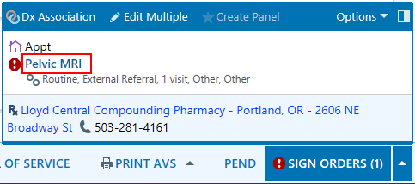
- Press F2 to utilize the SmartLists in the Comments box.
  - Type of imaging: In this example – MRI of Pelvis but patient has an allergy to contrast dye.
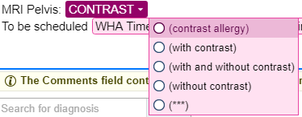
  - When the imaging should be scheduled:
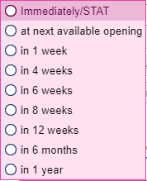
  - Which External Facility: 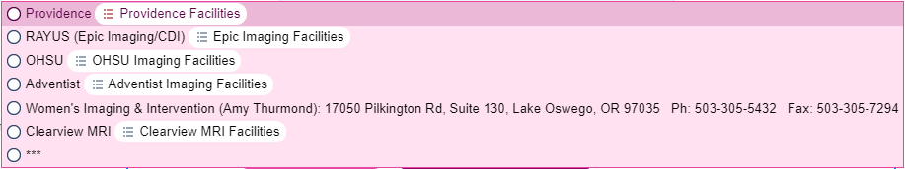
- Associate the appropriate diagnosis code. Consult with the clinician if it is unknown to you which would be best.
- Click Accept.
**Note: Clinical staff does not need to fill out any of the information in the Referral section of the order (The To loc/pos, To provider boxes) due to the information already residing in the Comments box. However, it can save time and work later on if it is added in the order.**
- Click Pend, this will hold the order for the provider to sign.

Once the provider has signed the imaging order the following steps can take place.

- If the order is for advanced imaging, such as an MRI or a CT scan, and a prior authorization is required you must wait to fax the order to the outside facility until the PA is AUTHORIZED.
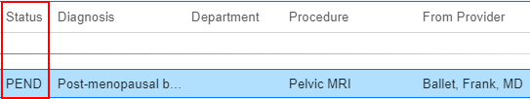
- Once approved, a Financial Coordinator will send a message to the Pod Pool with the PA number.
- If you’re sending an order to a Providence facility, please make sure to include the PA number on the order before faxing it over. Note that many Providence facilities are not accepting PA’s added to the fax cover sheet.
- Click How to make changes to signed external orders for steps on how to add a PA # to a signed External Order.
- The Clinical Services member must then call the patient to notify them the PA was approved if this has not been completed already.
  - It’s also highly recommended to give the PA number to the patient so they have the information as well.
  - The PA Number can be found by opening the referral from the Referral tab in Chart Review. It is at the top of the Referral Entry activity.
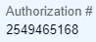
- After the patient has been notified the PA has been approved, the order can then be faxed to the external imaging facility.

How to Print the Order
- Go to Chart Review 
- Go to the Other Orders tab
- Single click the signed order to open the preview pane at the bottom of the screen.
- Click the Print button to send it to your local printer. (Make sure that your WHA Pod Printer is your default printer on the computer you’re working from).
- Print the order, have the clinician physically sign the order, then manually fax it to the facility chosen for the imaging. The fax number is located in the Comments section of the order.
**Note: For advanced imaging orders that require Prior Authorizations, the PA number must be included on the Cover Page once the PA has been approved.**
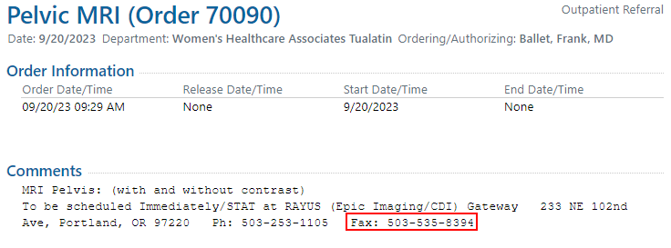

How to leave a note on the referral for tracking purposes

- Go to the Referrals tab in Chart Review.
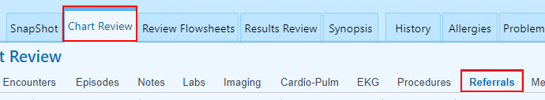
- Single click the order to open the preview pane at the bottom of the screen.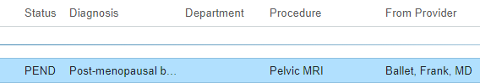
- In the Preview pane, check for the comments left by the ordering provider to see where the referral should be sent. This information will be in the Referral Notes section.
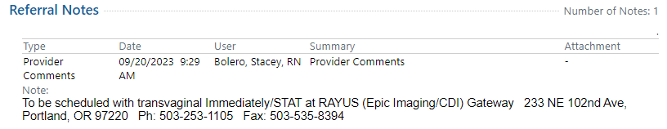
- Under Referral Information click the referral number hyperlink.
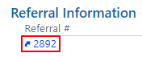
- Click Referred By/To if there is a Hard Stop. Use the available search field to enter in the location or specific provider the patient is being referred to.
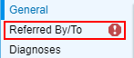
  - The referring location/provider can be found in the Communications activity under Provider Comments.
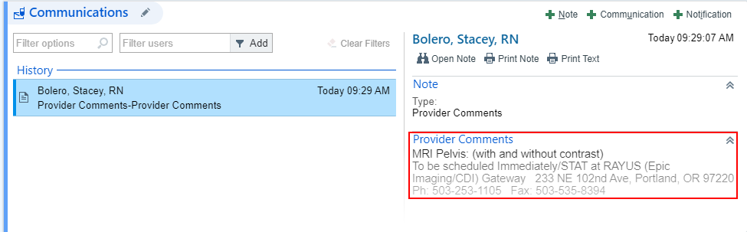
- Once the Hard Stop is resolved, click the Communications activity header to open it to be able to view all the Notes.
Now that the referral has been successfully faxed, a note must now be added to document the faxing has taken place. This note will help Referral Navigators easily see that the order has been faxed to the correct facility.
- Click the Note button in the top left corner of the Communications activity to create a new note.
- In the Note Type box that has a hard stop in it, type: General.
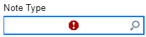
- In the free text box at the bottom type .WHAEXTERNALIMAGINGORDERFAXED.
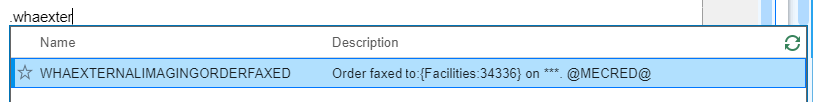
- Press F2 or click the highlighted variables to complete your documentation.

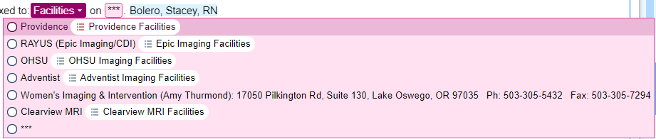
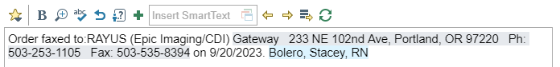
- Click Confirm.
- Click Close.
- Click Accept in the bottom task bar of the Referral Entry screen.
If you did not add a location or provider in the Referred By/To activity, follow the steps to complete this now.
- Epic will pop up with a box that notifies you of a hard stop that needs to be satisfied before finalizing the note. Click Go Back.
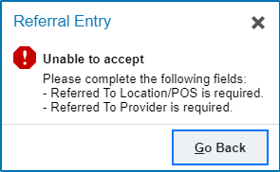
- In the Referred By/To activity will be two boxes with the hard stops. Choose one to search for the facility (Location/POS) or Provider (Provider & Address) that the order is being sent to. Once the hard stop is satisfied, click Close.

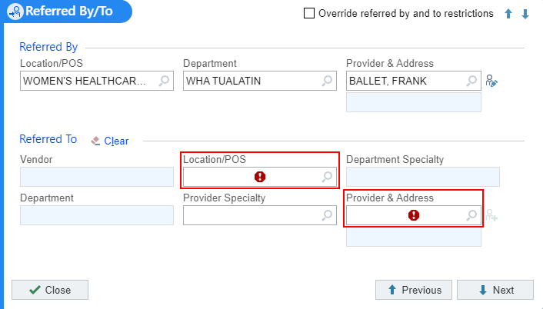
  - To make this easier use this spreadsheet to find how the name is listed in the Epic search box (this will be in the last column of the spreadsheet).
- Click Accept in the bottom task bar of the Referral Entry screen.
The Note can now be viewed in the Referral under the Referral Notes section.
